Timer

After pressing the clock button, a panel with four timers appears:

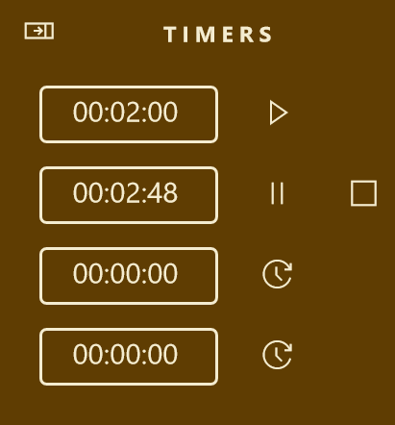

Set

Pause

Stop

Start a timer

The timers continue to run when you hide the panel. Once the time has elapsed, a bell rings. Note however, if the computer is in sleep mode, the timers will not work.